Data Project

By Shlok Saraf (23310)

Introduction:

In this Project we will Compare the relation between the Private Disposable income and the Household Consumption of Clothing and Footwear. We will use the Linear Regression with help of Python to find the values of R– squared and p-value. We will use the data of year 2014 to 2023

Research Question and relation the course, i.e. Macroeconomics-I(ECO204):

Question: Does the Private Disposable Income drives the Clothing and Footwear Consumption despite of Clothing Inflation?

This question is relevant to Chapter 4: Saving and Investment in Closed and

Open Economies, Topic: Private Saving.

Relation Eq:

$$Private Saving = Private Disposable Income - Consumption$$

$$Private Disposable Income∝Consumption$$

Data Source:

<https://www.mospi.gov.in/publication/national-accounts-statistics-2024>

Statement 1.3 (Disposable Income)

& 1.6 (Household Consumption of Clothing and Footwear)

<https://cpi.mospi.gov.in/Inflation_CurrentSeries_2012.aspx>

Inflation Rate

Data Analysis:

Step 1: Consumption-to-Income Ratio

$$Consumption-to-Income Ratio = \frac{Adjusted Consumption}{Disposable Income} *100$$

Purpose:

Measure the % of Income Spent in Consumption

Higher Ratio == Less Savings

Step 2: Income Elasticity of Consumption

$$Elasticity=\frac{\% Change in Consumption}{\% Change in Ratio}$$

Purpose:

Show sensitivity of Elasticity

Elasticity > 1 means Consumption grows faster than Income

Elasticity < 1 means Income grows faster than Consumption

Step 3: Regression Analysis

$$Consumption=⍺+β Disposable Income+ϵ$$

Purpose:

Check how the Consumption changes with Income, i.e. β.

Results:

|  |  |  |  |  |
| --- | --- | --- | --- | --- |
| Year | Adjusted Consumption | Disposable Income | Consumption-to-Income Ratio (%) | Elasticity |
| 2014 | 235161 | 8574640 | 2.74 |  |
| 2015 | 229740 | 9368021 | 2.45 | -0.25 |
| 2016 | 273721 | 10284723 | 2.66 | 1.67 |
| 2017 | 273374 | 11426086 | 2.39 | -0.01 |
| 2018 | 294753 | 12668081 | 2.33 | 0.71 |
| 2019 | 308653 | 14281383 | 2.16 | 0.37 |
| 2020 | 296470 | 15364343 | 1.93 | -0.36 |
| 2021 | 273662 | 15700320 | 1.74 | -0.76 |
| 2022 | 340426 | 17835727 | 1.91 | 1.89 |
| 2023 | 305901 | 20137930 | 1.52 | -0.93 |

Preforming Linear Regression we get,

⍺ = 186957.0

β = 0.007054

R-squared = 0.6260

Probability (F-statistic) = 0.006430

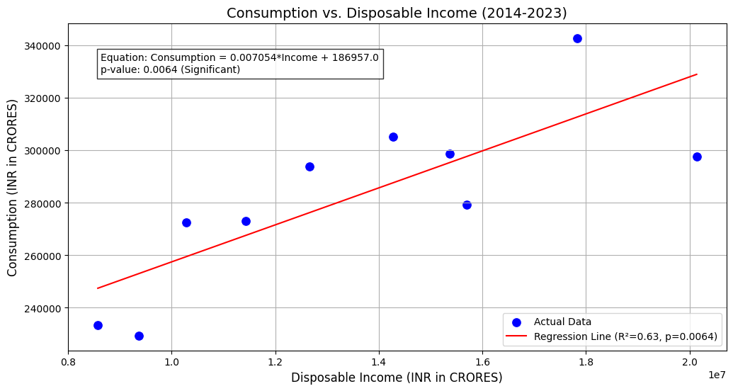

Conclusion:

From this we can conclude that,

* With increase in time, a smaller share of income is spent on Clothing. Reasons can be more savings and investments.
* Elasticity is varying widely which might be due to sudden external shocks like Pandemic.
* Disposable Income moderately drives the Clothing Consumptions, which explains the 62.6% of the Variance, While 37.4% is influenced by other factors.
* And, as the P-value is Statistically Significant (p<0.05) means Disposable income is significant predictor of Clothing Consumption.